**THE FEDORAS BOCCE CLUB MANUAL\***

Document Updates

1. Rules / Etiquette A. Renna
2. Teams - Rosters & Schedule (SAMPLE) R. Hagedorn
3. Round Robin for 3-6 Teams (How they Work) B. Entwistle
4. Play Options D. Trifiletti

(Create a team, Join Team, Sub for any team, Drop by)

1. Organization, Responsibilities, Operations D. Trifiletti
2. Courts, etc. Maintenance A. Renna
3. Flyers (Round Robin & Intro. To Bocce) N. Robbins

**\*Retrievable from HOA Calendar**

* Go to [CresswindLakewoodRanchHOA.com](http://CresswindLakewoodRanchHOA.com/) web site
* Select “LOGIN / Register” Register if new(Get PASSCODE from Carolina/Breeze)
* LOGIN
* Select CALENDAR option ( takes about 3 seconds to load )
* Type BOCCE in search section, click FIND EVENTS
* Click (or Double Click) on any BOCCE FLYER in calendar
* Look in DESCRIPTION section of Flyer shown at bottom
* Click on THE FEDORAS BOCCE CLUB MANUAL

**COURT LAYOUT**

-5 lines( center, 2 foul lines, 2 Pallino(small ball) out-of-play lines)

# TEAMS

* Try to have 5-7 players on team to cover absences, though flexible. Only 4 play in each game. Those not playing can be a SCAM(Scorekeeper, Coach and Measurer.) • Select a team Leader who will decide who will play in each game. Every player must play at least one game,
* Each player will toss 2 of 4 team balls. Order of the tosses can be decided by players on each side of the court.

# BASIC BOCCE RULES

1. Flip coin or other method to see which team is first to roll the Pallino.
2. Pallino must travel beyond the center line at 30 feet but no farther than the line 1 foot from the end of court(okay if on either line.) If Pallino doesn’t land in targeted area the Pallino is returned to the other team to toss.
3. The team who successfully rolled the Pallino throws first Bocce ball and is designated as Team A. Objective is to get as close to Pallino as you can. (If Rule 6 occurs, Team A continues to roll until Rule 6 doesn’t happen.)
4. Team B rolls their Bocce balls *until they have one closer to the Pallino* than that first ball rolled by Team A. Once Team B has one closer, play continues for Team A to get closer to the Pallino than the closest Team B ball and so on.
5. After all 8 Bocce balls are rolled, the only team that gets points is team with bocce balls closest to the Pallino. If ball “kisses” pallino, 2 points are awarded for that ball. The team scoring points also has control of the next pallino roll.
6. Note: A Bocce ball that is rolled all the way to the back wall, *without first hitting another Bocce Ball* *or the Pallino*, is removed from the court.
7. When measurements result in a tie, the team gaining the tie continues to deliver balls until they get closer to the pallino. If the frame (game has frames) ends in a tie, no points are scored for either team. The team that started the tied frame shall begin the next frame.
8. Only the player, who will be rolling the next ball, may go down the court to judge the position of the balls.
9. Play continues until a team scores enough points to end game. The number of Points required will be communicated by Scheduler

prior to team play, as it could vary depending on number of teams playing that night in the Round Robin. Team that wins game rolls the Pallino in next game. **OTHER RULES**

1. Bocce balls bouncing out of court are “out of play” (dead).
2. If a bocce ball knocks the pallino out of the court, the Pallino is returned to court by placing it on “the center of the 1’ foul line”and play continues. The next team to throw will be the team not closest to the newly positioned Pallino.
3. When a bocce ball is delivered out of turn, the offending side will lose that ball. Any balls repositioned as a result of this offending ball will remain as they are.
4. If a team delivers a ball of the other team, it loses a ball and the delivered ball will be returned to the opposing team for play. All ball movement caused by the ball thrown in error stay as they are.
5. Only league balls shall be used for all league games. Mixing wooden and different size balls with the league resin balls can damage balls and cause inconsistent play.
6. Measure from the edge of bocce ball to the center top of Pallino using tape or cup. If the measurers or a player on the court inspecting the balls layout

inadvertently move any bocce balls or the pallino, the leaders have the option to reposition the moved balls and continue. If the leaders can’t agree on a repositioning, then the frame (game has frames) shall be void. Balls are sent to the other side and the team that started the voided frame shall begin the frame.

1. Balls are rolled not lofted into the air. Lofting causes small craters in court and can be dangerous. Any severally lofted ball will be removed from court.

# BOCCE ETIQUETTE

1. Be prompt for the day’s scheduled start times. In Round Robin play, succeeding games play can begin immediately after both teams in their bracket are ready.
2. Be ready when it’s your turn to roll.
3. Good manners are common sense and a courtesy

-Have a positive attitude, Have Fun!

-Learn and Play by the rules

-Treat all with respect. Do not criticize, tease, taunt or bully

-Take pride in winning but don’t rub it in

-In general, be helpful to teammates and competition.“Helpful Hints” on play details is best offered only when asked.

-Avoid profanity

1. After a frame is complete, those responsible for measuring should roll balls to the area of the balls holder. Those, whose turn it is to play, should return balls to the holder.
2. Cell phone calls should be taken away from the playing area.
3. Keep materials in Bocce Container in good order: One bag(yellow/blue balls/pallino), other bag(green/red balls/pallino), measuring devices, etc.
4. Do not play when courts have standing water. Okay to play if damp to touch.

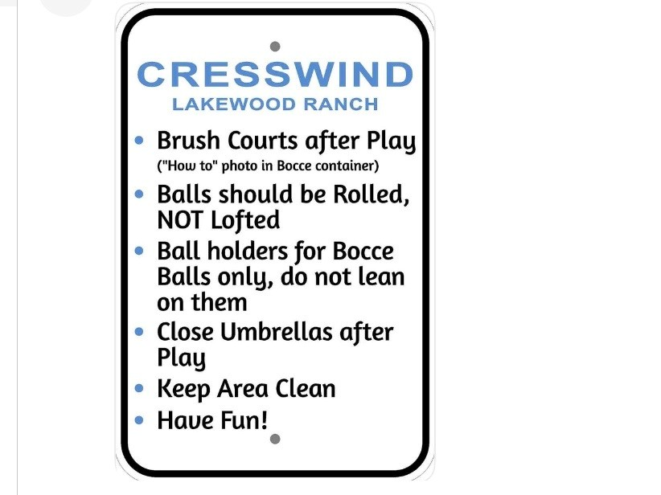

BOCCE TEAMS - APRIL 2025 Updated 4/01/25

|  |  |  |  |  |  |  |  |  |  |  |  |  |  |  |  |  |  |  |  |  |  |  |  |  |  |  |  |  |  |  |  |  |  |  |  |  |  |  |  |  |  |  |  |  |  |  |  |  |  |  |  |  |  |  |  |  |  |  |  |  |  |  |  |  |  |  |  |  |  |  |  |  |  |  |  |  |  |  |  |  |  |  |  |  |  |  |  |  |  |  |  |  |  |  |  |  |  |  |  |  |  |  |  |  |  |  |  |  |  |  |  |  |  |  |  |  |  |  |  |  |  |
| --- | --- | --- | --- | --- | --- | --- | --- | --- | --- | --- | --- | --- | --- | --- | --- | --- | --- | --- | --- | --- | --- | --- | --- | --- | --- | --- | --- | --- | --- | --- | --- | --- | --- | --- | --- | --- | --- | --- | --- | --- | --- | --- | --- | --- | --- | --- | --- | --- | --- | --- | --- | --- | --- | --- | --- | --- | --- | --- | --- | --- | --- | --- | --- | --- | --- | --- | --- | --- | --- | --- | --- | --- | --- | --- | --- | --- | --- | --- | --- | --- | --- | --- | --- | --- | --- | --- | --- | --- | --- | --- | --- | --- | --- | --- | --- | --- | --- | --- | --- | --- | --- | --- | --- | --- | --- | --- | --- | --- | --- | --- | --- | --- | --- | --- | --- | --- | --- | --- | --- | --- | --- |
| |  |  |  |  |  |  |  |  |  |  |  |  | | --- | --- | --- | --- | --- | --- | --- | --- | --- | --- | --- | --- | | Teams/* Leaders | 4/3 | 4/4 | 4/4 | 4/5 | 4/11 | 4/11 | 4/18 | 4/19 | 4/24 | 4/25 | 4/25 | |  | 6:30 PM | 4:00 PM | 6:30 PM | 9:30 AM | 4:00 PM | 6:30 PM | 4:00 PM | 9:30 AM | 6:30 PM | 4:00 PM | 6:30 PM | |  | THUR | FRI | FRI | SAT  1 slot open | FRI | FRI | FRI | SAT  2 slots open | THUR  1 slot open | FRI | FRI  1 slot open | | FULL | FULL | FULL | FULL | FULL | FULL | FULL | |  |  |  |  |  |  |  | | **LET'S ROLL** |  |  |  |  |  |  |  |  |  |  |  | | YES | YES | | *Deb Kollet  *Kristen Kullman  Rinkje Zondor  Catherine Rutigliano Maria Rose  **BOCCE BALBOA** |  |  |  |  |  |  |  |  |  |  |  | | YES | YES | | *Terrie & Gary Baker  Kathy & Jim Flora  Mary & Frank Abram  **BOCCE BOUNCERS** | |  |  |  |  |  |  |  |  |  |  | | YES | YES | | *Bruce & Laura Ent  Len Mathey  Arvind & Rekha Sha  Jenny Bemis-Dropp Amelia Harding  **THE GOOMBAHS** | wistle  h  ert |  |  |  |  |  |  |  |  |  |  | | YES | YES | | *Cindy & Les Abel  Sarita & Jim Garriso  Eliane & Paul Wentz | n |  |  |  |  |  |  |  |  |  |  | | |  | | --- | | FULL = All slots filled | | for date/time | |
| |  | | --- | | Host Team Assigned | | Responsibilities: | | 1) Lead Round Robin | | and Keep Score | | (Bring Score Sheet | | for number of teams) | | 2) Take Photo, Post | | on Group Me | | 3) Rake Courts, | | Umbrellas Down | |

|  |  |  |  |  |  |  |  |  |  |  |  |
| --- | --- | --- | --- | --- | --- | --- | --- | --- | --- | --- | --- |
| Teams/* Leaders | 4/3 | 4/4 | 4/4 | 4/5 | 4/11 | 4/11 | 4/18 | 4/19 | 4/24 | 4/25 | 4/25 |
|  | 6:30 PM | 4:00 PM | 6:30 PM | 9:30 AM | 4:00 PM | 6:30 PM | 4:00 PM | 9:30 AM | 6:30 PM | 4:00 PM | 6:30 PM |
|  | THUR | FRI | FRI | SAT | FRI | FRI | FRI | SAT | THUR | FRI | FRI |
| **BOCCE BALLERS** |  |  |  |  |  |  |  |  |  |  |  |
| YES | YES |
| *Mike Osborn (Ozzi  Mary & Cathy Walsh  John Ledford  Ted & Sophie Konya  **THE ROLLING STON** | e) |  |  |  |  |  |  |  |  |  |  |
| YES | YES | YES |
| *Dee & Don Treinen  Lori & Jay Manik  Monica & Larry Sand  Ilana & Dan McCarthy  **GAME OF THROWS (GOT)** | |  |  |  |  |  |  |  |  |  |  |
| YES | YES |
| *Robyn & Barry Hag  Patty Malloy  Steven & Mary Kow Lynne Turkus  **HAVING A BALL** | edorn  alski |  |  |  |  |  |  |  |  |  |  |
| YES | YES |
| *Shawne & Mike Pe  Laura & Joe Monins  Sophia McArdle | car  ki |  |  |  |  |  |  |  |  |  |  |

|  |  |  |  |  |  |  |  |  |  |  |  |
| --- | --- | --- | --- | --- | --- | --- | --- | --- | --- | --- | --- |
| Teams/* Leaders | 4/3 | 4/4 | 4/4 | 4/5 | 4/11 | 4/11 | 4/18 | 4/19 | 4/24 | 4/25 | 4/25 |
|  | 6:30 PM | 4:00 PM | 6:30 PM | 9:30 AM | 4:00 PM | 6:30 PM | 4:00 PM | 9:30 AM | 6:30 PM | 4:00 PM | 6:30 PM |
|  | THUR | FRI | FRI | SAT | FRI | FRI | FRI | SAT | THUR | FRI | FRI |
| **ROCKIN ROLLERS** |  |  |  |  |  |  |  |  |  |  |  |
| YES | YES | YES |
| *Ninette & Tim Rob  Doris Hopkins  John & Michelle Pot    **HOLY ROLLERS** | bins ocko |  |  |  |  |  |  |  |  |  |  |
| YES | YES |
| *Patty Zoller  Jerry Bassett  Cynthia Prell  Jonathan Eskridge  Marie Nell  Dennis Tanner  **CANNON BALLERS** |  |  |  |  |  |  |  |  |  |  |  |
| YES | YES |
| *Mark & Diana Pearson  John & Linda Bargull  Fran & Trish McLoughlin | |  |  |  |  |  |  |  |  |  |  |
| **HIGH ROLLERS** | YES | YES |
| *Mike & Renee Brayton  Peter & Susan Moon  Patti & Jim Valenti  Fred & Rochelle Bonaccorso | |  |  |  |  |  |  |  |  |  |  |

|  |  |  |  |  |  |  |  |  |  |  |  |
| --- | --- | --- | --- | --- | --- | --- | --- | --- | --- | --- | --- |
| Teams/* Leaders | 4/3 | 4/4 | 4/4 | 4/5 | 4/11 | 4/11 | 4/18 | 4/19 | 4/24 | 4/25 | 4/25 |
|  | 6:30 PM | 4:00 PM | 6:30 PM | 9:30 AM | 4:00 PM | 6:30 PM | 4:00 PM | 9:30 AM | 6:30 PM | 4:00 PM | 6:30 PM |
|  | THUR | FRI | FRI | SAT | FRI | FRI | FRI | SAT | THUR | FRI | FRI |
| **BALLS OF FURY** |  |  |  |  |  |  |  |  |  |  |  |
| YES | YES |
| *Jan & Duane Jones  Dianna & Glenn Ker  Tom Van Der Veer Rosanne Nagler  **BOCCE AMICI** | snick |  |  |  |  |  |  |  |  |  |  |
| YES | YES |
| *Robert & Laura Ski  Nick & Christine We  Deb & Jim Fitzgerald Beth & Mark Lakis  **PALLINO PALS** | ffey  tton |  |  |  |  |  |  |  |  |  |  |
| YES | YES |
| *Peggy & Bob Riem  Carol Carstens  Bill Powell  Moe & Ed Gregg  Joye & John Lucking  **VAGABONDOS** | an |  |  |  |  |  |  |  |  |  |  |
| YES | YES |
| *Susan Solz & Alan Kessler  Maddy & Eric Sternberg  Todd & Jackie Morgan  Sandra & Larry Bronstein | |  |  |  |  |  |  |  |  |  |  |

|  |  |  |  |  |  |  |  |  |  |  |  |
| --- | --- | --- | --- | --- | --- | --- | --- | --- | --- | --- | --- |
| Teams/* Leaders | 4/3 | 4/4 | 4/4 | 4/5 | 4/11 | 4/11 | 4/18 | 4/19 | 4/24 | 4/25 | 4/25 |
|  | 6:30 PM | 4:00 PM | 6:30 PM | 9:30 AM | 4:00 PM | 6:30 PM | 4:00 PM | 9:30 AM | 6:30 PM | 4:00 PM | 6:30 PM |
|  | THUR | FRI | FRI | SAT | FRI | FRI | FRI | SAT | THUR | FRI | FRI |
| **ROLL MODELS** |  |  |  |  |  |  |  |  |  |  |  |
| YES | YES |
| *Karen Buehring  Lou Vitale  Donna Geraldi  Linda Siggia  Ken Wood  Angelo Renna Gino Alfano  **BOCCE THUNDER** |  |  |  |  |  |  |  |  |  |  |  |
| YES | YES | YES |
| *Pam & John Boban  Kathy & Mike Cannon  Martina & Gary Fren | ch |  |  |  |  |  |  |  |  |  |  |

We use a Round Robin format. See formats below

for:

* Six Teams
* Five Teams
* Four Teams (Current - Most common & Ideal)
* Three Teams(Current)

|  |  |  |  |  |  |
| --- | --- | --- | --- | --- | --- |
| Bocce 6 team round robin | | | |  |  |
| All teams play 4 games Winner: first to 8 points | | |  |  |  |
| Please remain conscious of time to ensure all teams get to play | | |
|  |  |  |
| Teams: |  |  |  |  |  |
| 1: |  |  | 4: |  |  |
| 2: |  |  | 5: |  |  |
| 3: |  |  | 6: |  |  |
|  |  |  |  |  |  |
| Round | Court 1 | Court 2 | Winner Court 1 | Winner Court 2 | Byes: |
| 1 | 1 x 2 | 3 x 4 |  |  | 5 - 6 |
| 2 | 3 x 6 | 1 x 5 |  |  | 2 - 4 |
| 3 | 2 x 5 | 4 x 6 |  |  | 1 - 3 |
| 4 | 1 x 3 | 2 x 4 |  |  | 5 - 6 |
| 5 | 2 x 6 | 3 x 5 |  |  | 1 - 4 |
| 6 | 4 x 5 | 1 x 6 |  |  | 2 - 3 |
|  |  |  |  |  |  |

|  |  |  |  |  |  |
| --- | --- | --- | --- | --- | --- |
| Bocce 5 team round robin | | | |  |  |
| All teams play 4 games Winner: first to 8 points | | |  |  |  |
| Please remain conscious of time to ensure all teams get to play | | |
|  |  |  |
| Teams: |  |  |  |  |  |
| 1: |  |  | 4: |  |  |
| 2: |  |  | 5: |  |  |
| 3: |  |  |  |  |  |
|  |  |  |  |  |  |
| Round | Court 1 | Court 2 | Winner Court 1 | Winner Court 2 | Byes: |
| 1 | 1 x 2 | 3 x 4 |  |  | 5 |
| 2 | 2 x 3 | 4 x 5 |  |  | 1 |
| 3 | 2 x 4 | 1 x 5 |  |  | 3 |
| 4 | 1 x 4 | 3 x 5 |  |  | 2 |
| 5 | 2 x 5 | 1 x 3 |  |  | 4 |
|  |  |  |  |  |  |

|  |  |  |  |  |  |
| --- | --- | --- | --- | --- | --- |
| Bocce 4 team round robin | | | |  |  |
| All teams play 3 games Winner: first to 8 points | | |  |  |  |
| Please remain conscious of time to ensure all teams get to play | | |
|  |  |  |
| Teams: |  |  |  |  |  |
| 1: |  |  | 3: |  |  |
| 2: |  |  | 4: |  |  |
|  |  |  |  |  |  |
| Round | Court 1 | Court 2 | Winner Court 1 | Winner Court 2 |  |
| 1 | 1 x 2 | 3 x 4 |  |  |  |
| 2 | 1 x 3 | 2 x 4 |  |  |  |
| 3 | 2 x 3 | 1 x 4 |  |  |  |
|  |  |  |  |  |  |

|  |  |  |  |  |  |
| --- | --- | --- | --- | --- | --- |
| Bocce 3 team round robin | | | |  |  |
| All teams play 2 games Winner: first to 8 points | | |  |  |  |
| Please remain conscious of time to ensure all teams get to play | | |
|  |  |  |
| Teams: |  |  |  |  |  |
| 1: |  |  | 3: |  |  |
| 2: |  |  |  |  |  |
|  |  |  |  |  |  |
| Round | Court 1 |  | Winner Court 1 |  | Byes: |
| 1 | 1 x 2 |  |  |  | 3 |
| 2 | 2 x 3 |  |  |  | 1 |
| 3 | 1 x 3 |  |  |  | 2 |

**Procedures for [Creating, Joining, or Subbing on a Team ]or Occasional nonTeam Play**

**First**, attend an **INTRO to BOCCE date, time and location varies. See current Flyer.** Ang (Angelo Renna or Dee Trifiletti) will share the easy rules at the clubhouse and then we’ll go out to the courts, randomly pick teams and play for as long as you want( courts have lighting.)

After this introduction and you have learned some simple bocce rules,

## If you wish to create a Team

* Teams require a minimum of 4 dedicated players, and preferably 5-6 players ( including Subs.) During play one member will act as a SMAC(Scorer, Measurer and Coach)
* Play is on Friday nights; First Friday, 4-6pm, all others 6:30 – approx.. 8:30 or end of play.
* If wish to create a team, email Dee: datrifiletti@att.net and provide her with your:
* Team Name ( Google Bocce Team Names if looking for ideas - Shows about 350 names )
* Team Leader Name & Email
* Team Members Names & Email addresses.

• There are two **Group Me** groups.

1. Bocce Club - Cresswind LWR
2. Bocce Team Leaders - Cresswind LWR

-Leaders should join Groups 1 & 2 and advise their members to join Group 1. By joining Group Me, members will receive ongoing communications. -After Group Me is downloaded ( if you already haven’t ), they should then email ShawnePecar@gmail.com and ask her to add you to the appropriate bocce Group Me group or groups.

-The Leader will be responsible for coordinating the dates that your members can play for the following month and informing Robyn Hagedorn via Group Me of your confirmed team attendance (of at least 4 players) by the 15th of the month prior to the month play is scheduled.

The assigned HOST Team Leader will facilitate the Round Robin, keep score, take a photo of winner, send photo to ShawnePecar@gmail.com for Group Me and Facebook posting.

**If** **you wish to join an Existing Bocce Team OR be a SUB for a team?**

If so, Email Dee: datrifiletti@att.net (SUBJECT- BOCCE) with your Name & Your Interest and we will try to accommodate your request and inform you when an opening arises.

**If you wish to just play occasionally, i.e., not team play.**  Playany day/time other than scheduled TEAM Round Robins or Intro to Bocce nights. Balls & Rules are in container near the benches by the court.

**The FEDORAS Bocce Club Organization, Responsibilities & Operations**

**Committees:**

* **HOA Board Interface, Rules & Club Operations -** Angelo

Renna (Emmamargo1234@gmail.com) & Dee

Trifiletti(datrifiletti@att.net)

. maintain a single link with all Bocce docs for HOA site and Breeze calendar (Ang)

. update/ensure latest laminated version of Rules in bin ( Ang with Terrie Baker assistance)

* **Administration & Communications** – Dee

. Maintain Email List & send emails re: important info, mtgs …

. Recruit and support Team Leaders & Members

. Help to create New Teams

* **Marketing** - Dee

. INTRO TO Bocce: to teach newbies and recruit new members/ teams

. Solicit interest/Attains emails at other Social Club events, i.e. Pickleball, Singles Ang/Dee

. Create & Maintain Flyers;

Ninette(ninette.robbins@gmail.com) supply copies to Breeze for TV, flyer rack and HOA Calendar

. Post Flyers on Facebook & Group Me: Shawne Pecar(shawnepecar@gmail.com)

* **Treasurer** – Mike Osborne/Ozzie (ozziemike@verizon.net)

. maintain Treasury Reports, collect dues/donations

* **Secretary** – Terrie Baker (terriebaker78@gmail.com) ; record meeting minutes
* **Fun Committee** – Jenny (Jennybemis12@gmail.com) . Plan and implement special events (attain Committee/Leader input & solicit resources)
* **Ongoing Court Maintenance/Prep –** Breeze with Tim

Robbins assistance

-**TEAM LEADERS**

1. **Scheduling** – Robyn & Team Leaders:

Set up a system to communicate with your team members ongoing.

Most importantly, ask your members about their availability for the following months play.

**Summarize your teams top 3 choices and then** **send choices to Robyn (pillowscape@verizon.net) or post of Bocce Leaders Group Me App. *** by her designated date.**

Robyn will compile your requests and advise you of the final schedule on Group Me

by the first of each month. Mark your calendar to check

the final schedule each month, and inform your team members of the dates and members who will be playing .

**Currently (April 2025) our available days/times are as follows:**

**. 1st & 3rd Thursday/month, 6:30 pm**

**. every Friday/month, 4:00 & 6:30 pm**

**Note: Breeze event is now the 3rd Friday/month, 6:00**

**. every Saturday/month, 9:30 am**

**IMPT: see the HOA calendar for most current schedule.**

* Reserving a date requires a minimum of 4 team members who are available to play.

If emergencies occur and you do not have 4, **request a Sub on the main Group Me app.** If no one responds, you can play with 2-3 players, but it is not preferable because there may be other full teams who would like to play!

* Remember that you can **always practice or play ANYTIME/ ANYTIME.**

And you can invite other teams to join you with a post on Leader Group Me.

i.e. our team would like to play regularly on Wed, at 6:30; any other Team interested?

If you have three or more teams who wish to play a Round Robin regularly, ask Robyn to add the new day/time on the schedule.

* If your team would like a Hiatus for a month(s), please inform Robyn of such by her designated date.

Ensure Team Hosts/ All Leaders have current Round Robin formats hard copy & laminated in bin.

Bruce Entwistle

. Coordinate the schedule with Breeze for postings on Calendar – Bruce

**2. HOST TEAM**: A host will show in green on the Team Roster/Schedule; note the HOST responsibilities listed in green box.

**\* Print the appropriate Scoring/Round Robin Form (for**

**the appropriate # teams playing that night).**

**Fill in your team names so you are ready when you start playing at your scheduled time and to avoid confusion and to start promptly.**

**To access the forms (within the Club Manual): go to the HOA calendar, login, select Calendar, type Bocce in search section, click find events, click on any Bocce Flyer, go to description at bottom, click on the Bocce Club Manual. Your scoring /RR forms are included in Manual.**

**You will keep score of winners, take a photo of winning team with a Fedora Hat.**

**(bring yours to loan to winning Team Leader*) and then post on Bocce Group Me page & Facebook (if you can).**

If need help, send photo to ShawnePecar@gmail.com. *If you don’t have a Fedora Hat, email Dee and she will get one to you.

**It is important to lower umbrellas, clean the area, and rake courts**

**(‘how to’ instructions) are in the storage bin by the courts.**

**Be sure to wrap Velcro strap around the umbrella and the pole!**

1. **MEETINGS:** Ensure that you **attend the infrequent but important meetings** as scheduled.

If you cannot attend, select a team member to sub for you.

1. **CLUB RULES MANUAL**: **familiarize yourself with the comprehensive manual on the HOA website.**

Address any questions to Angelo Renna, emmamargo1234@gmail.com.

Send the manual to all of your team members so that they too, are aware of the Rules/Etiquette, etc. You can access this Club Manual on the HOA website (see 2. Above).

**BOCCE COURTS, etc. MAINTENANCE**

### Court Specifications

* Surface is HAR TRU(Brand) very small green stone(clay)
* Border is TREX(Brand) composite boards attached to pressure treated wood(PTW.)
* Two irrigation pipes and water “tub” beneath Har Tru slowly feeding clay • Dimensions / 5 “Lines” on court (see photo)

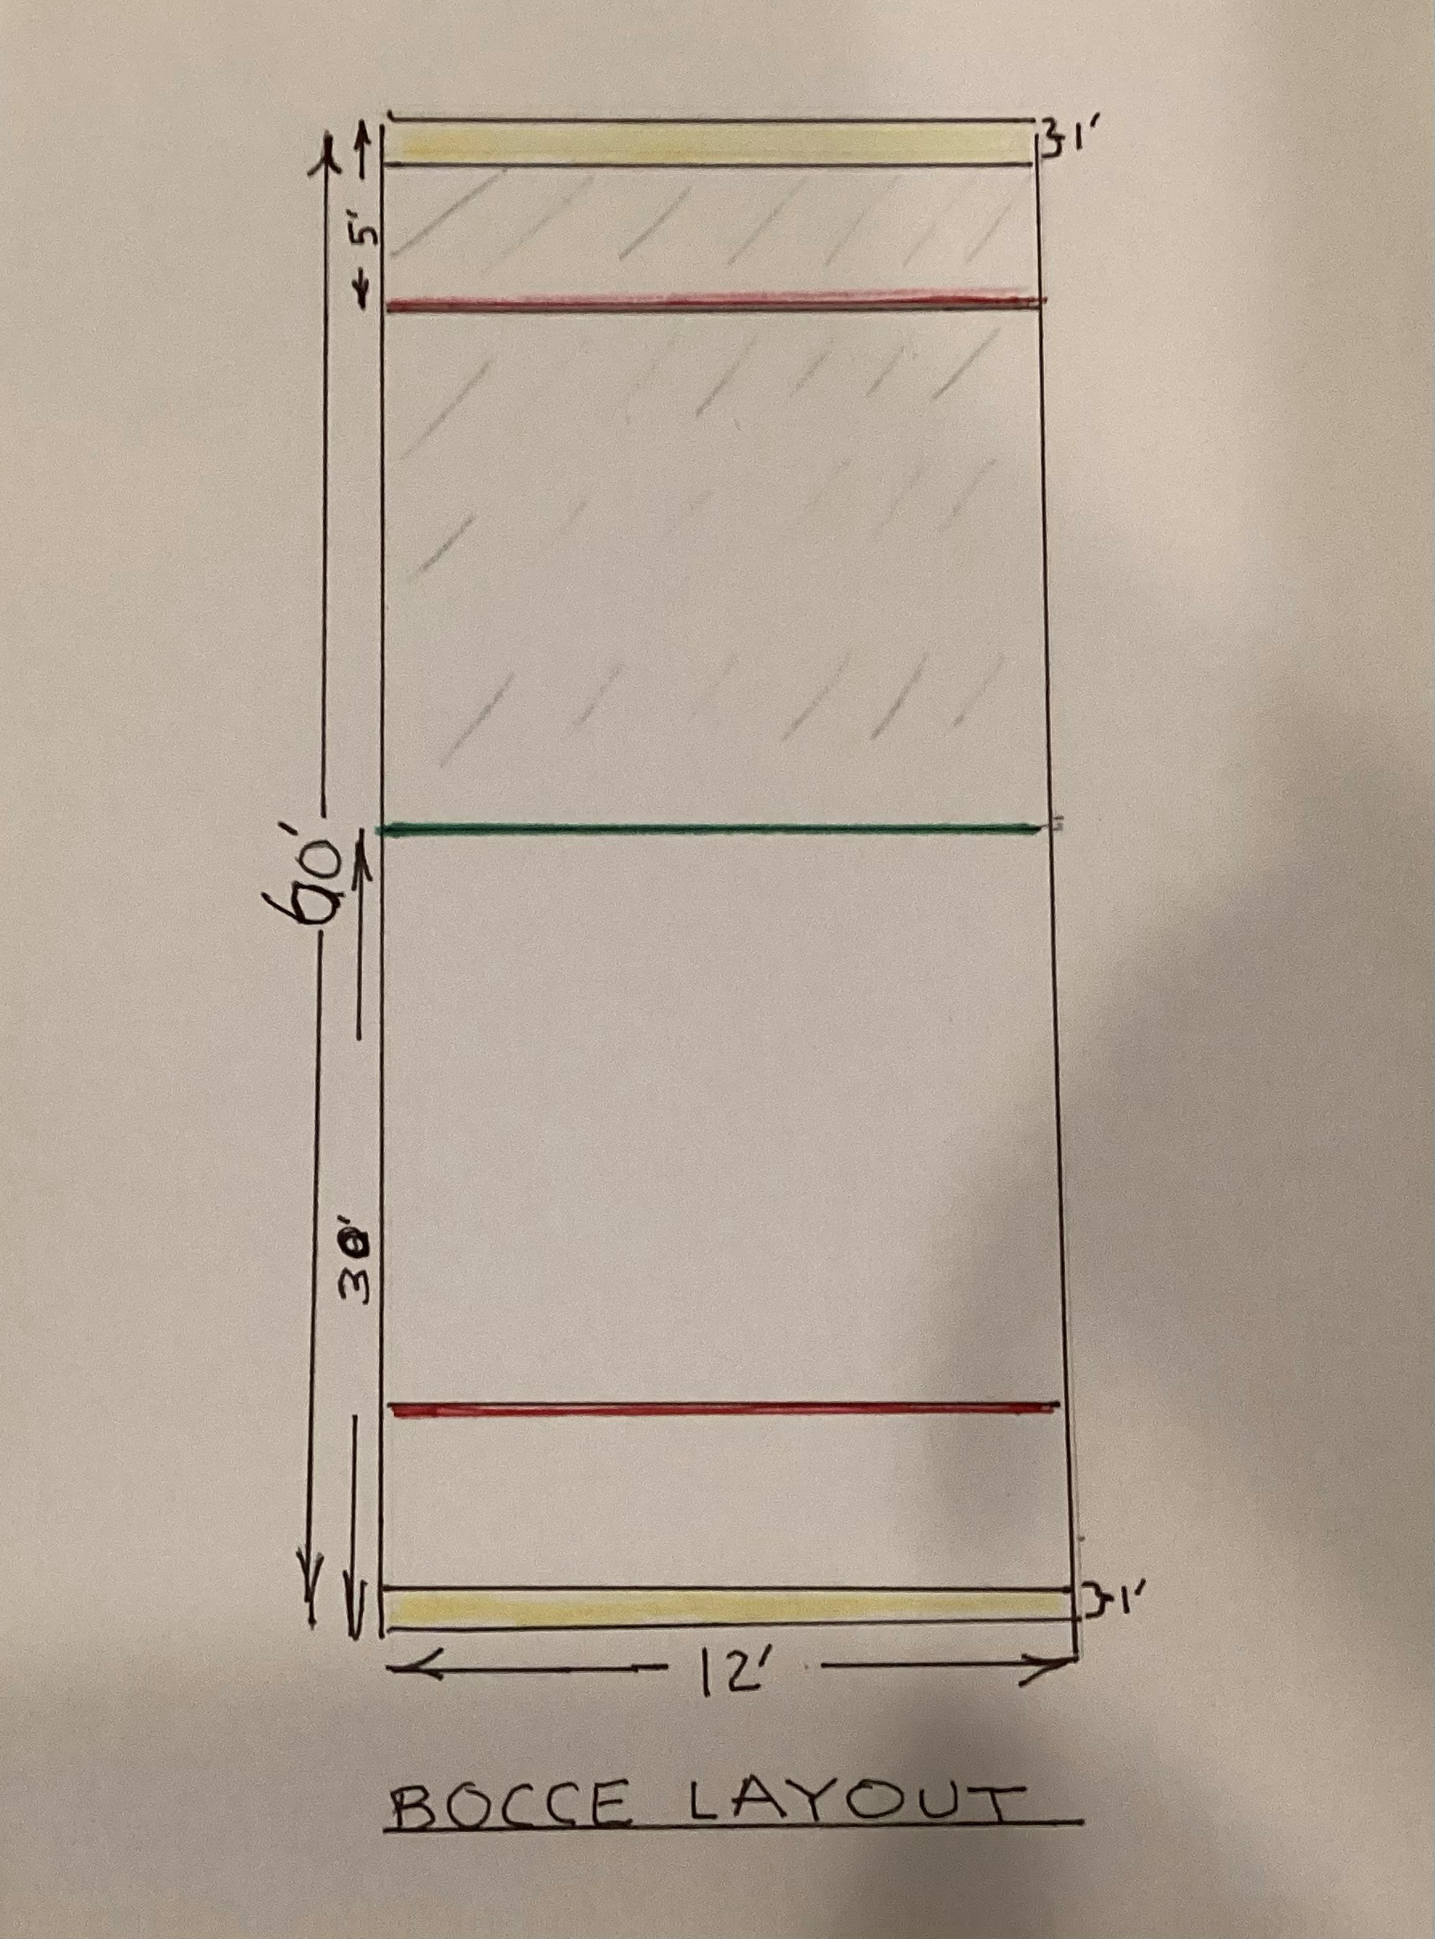

### Har Tru Surface Maintenance

* Clay requires periodic replenishment. The estimated quantity required is 20 fifty pound bags per court per year. HOA annual budget need is roughly $600 (40 bags x $15/bag(Dec2024.) If ball not rolling true to intended line, court could need additional clay for leveling. When rub a finger across clay, should see about 1/8” depression, if not, need more clay.
* Two “Rakes”, Line Sweeper, household broom/dust pan and a roller machine are available to prepare surface for play:

-2 wide Brush Brooms with soft bristles. Move down each side of court with soft bristles side(metal edge side should only be used by Breeze Maintenance Supervisor.)

-1 small (roughly 2” wide) Line Sweeper is used to mark five court lines as shown above. These raked lines should align with painted (red, green, yellow) distance markers on the Trex.

-Use 1 household broom / dust pan to smooth out any accumulated stone around edges and sweep pavers.

-Breeze Maintenance Supervisor will use Broom with hard aluminum bristles and roller machine(filled with water) as needed. These should not be used by players.

* Raking / Rolling Schedule and Responsibility:

- Breeze Property Manager(Josh Jones can review bocce schedule on HOA calendar.

When on site, Breeze Maintenance Supervisor(Yuri Banny) will prepare surface, including

5 lines prior to team play.

-Breeze Maintenance Supervisor will rake courts routinely on Monday, Wednesday and Friday. Normally Supervisor will use brush end and only Supervisor should use straight edge when judged to be needed for severe uneven surface.

-During team play, if needed, host team leader assures that courts are raked.

At the end of play that day, host team leader will assure that courts are raked and lined.

Any team’s member can of course volunteer to do the raking and lining.

Should only use brush side of broom as shown, not straight edge.

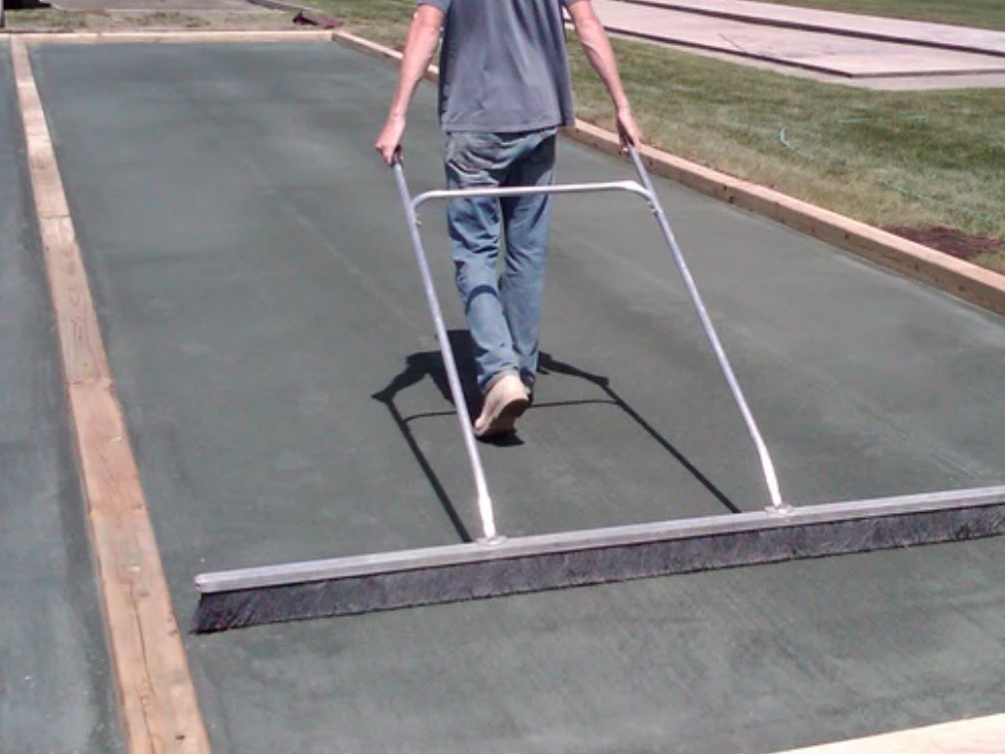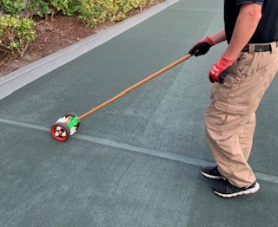

• Court Irrigation

-When activated manually, system feeds water to tub below the surface which in turn feeds two pipes below the surface on each court.

-When operating properly, water is seeped to the stone 24 x 7. Visually court surface should be a light green. If looks light sandy color, court is not getting enough water. If looks very dark, court is getting too much water.

-Breeze maintenance supervisor will monitor the court condition,

will resupply water to courts underside as needed or sprinkle water on surface if needed and notify Property Manager if not operating properly.

### TREX Borders Maintenance

* Any warped or damaged boards ( especially those on inside sides that are used for play ) will be refastened or replaced, with management by Breeze. Current cost, December 2024, to replace TREX about $4/foot.
* Breeze will maintain quality of line markers ( red, green, yellow) painted on TREX.

### Shellock Pavers

Pavers are installed in the walkway between courts and on the North backside of courts. Shellock pavers should not be sealed but Breeze Maintenance Supervisor will pressure wash and apply sand between pavers as needed. Pavers are not “cemented” to ground. Team host should assure pavers are swept after play. Clay can be returned to court.

### Landscaping Drainage Control

To prevent heavy rains and landscaping irrigation, on the left of the West Court and the right of the East Court, from seeping onto those courts a drainage pipe in trench was installed and will be maintained by Breeze/Landscape Contractor. Also, there are two drainage covers on the

West side and two on the East that need to be kept clear of landscape debris by Breeze/ Landscape Contractor.

### Annual Quality Check

Once per year, Breeze will arrange for a complete courts’ quality inspection by an outside contractor and implement feasible recommended changes to courts. Findings and planned actions will be communicated to current bocce club co-chairs, Dee Trifiletti and Angelo Renna.

### Elevated Ball Holders Maintenance

• Breeze will maintain the stability of the 4 structures. They consist of the purchased top and the Breeze-constructed wooden struts. Elevation should be maintained at roughly 2’ above top of TREX board.

### Lighting

* Since team play is currently mostly in the evenings (6:30 - 8:30). If lighting problem can’t be remedied in time for team play, notify Angelo Renna (emmamargo1234@gmail.com) *and* Dee

Trifiletti (datrifiletti@att.net).

* Lighting control knob can be set to a max of one hour so may need to be reset as team play approaches one hour.

Be aware that power availability to court lighting is controlled by Breeze in a locked area.

It was reset to 4pm from 5:30 to avoid

potential issues going off daylight savings time.

Breeze will assure that power is available during span of evening hours play.

### Bocce Balls Replacement

• A set of balls will require periodic replacement as they will dent and wear over time.

Balls shout be resin ( not plastic) and 107mm in diameter, pallino 53mm in diameter. One set should be ( yellow, blue), the other ( red, green) to match the scoreboard sliding discs. The pallino in each set should be a contrasting color to balls in set.

### Equipment Container

* All users will maintain in good order the contents of the club container. Equipment includes two buckets ( one blue, one red) of team balls, one for each court. Also includes 2 sets of older “practice” balls, measuring devices, laminated sheet of rules, round robin sheets, “how to” use brushes, “how to” use umbrellas, etc. ( See photo below )

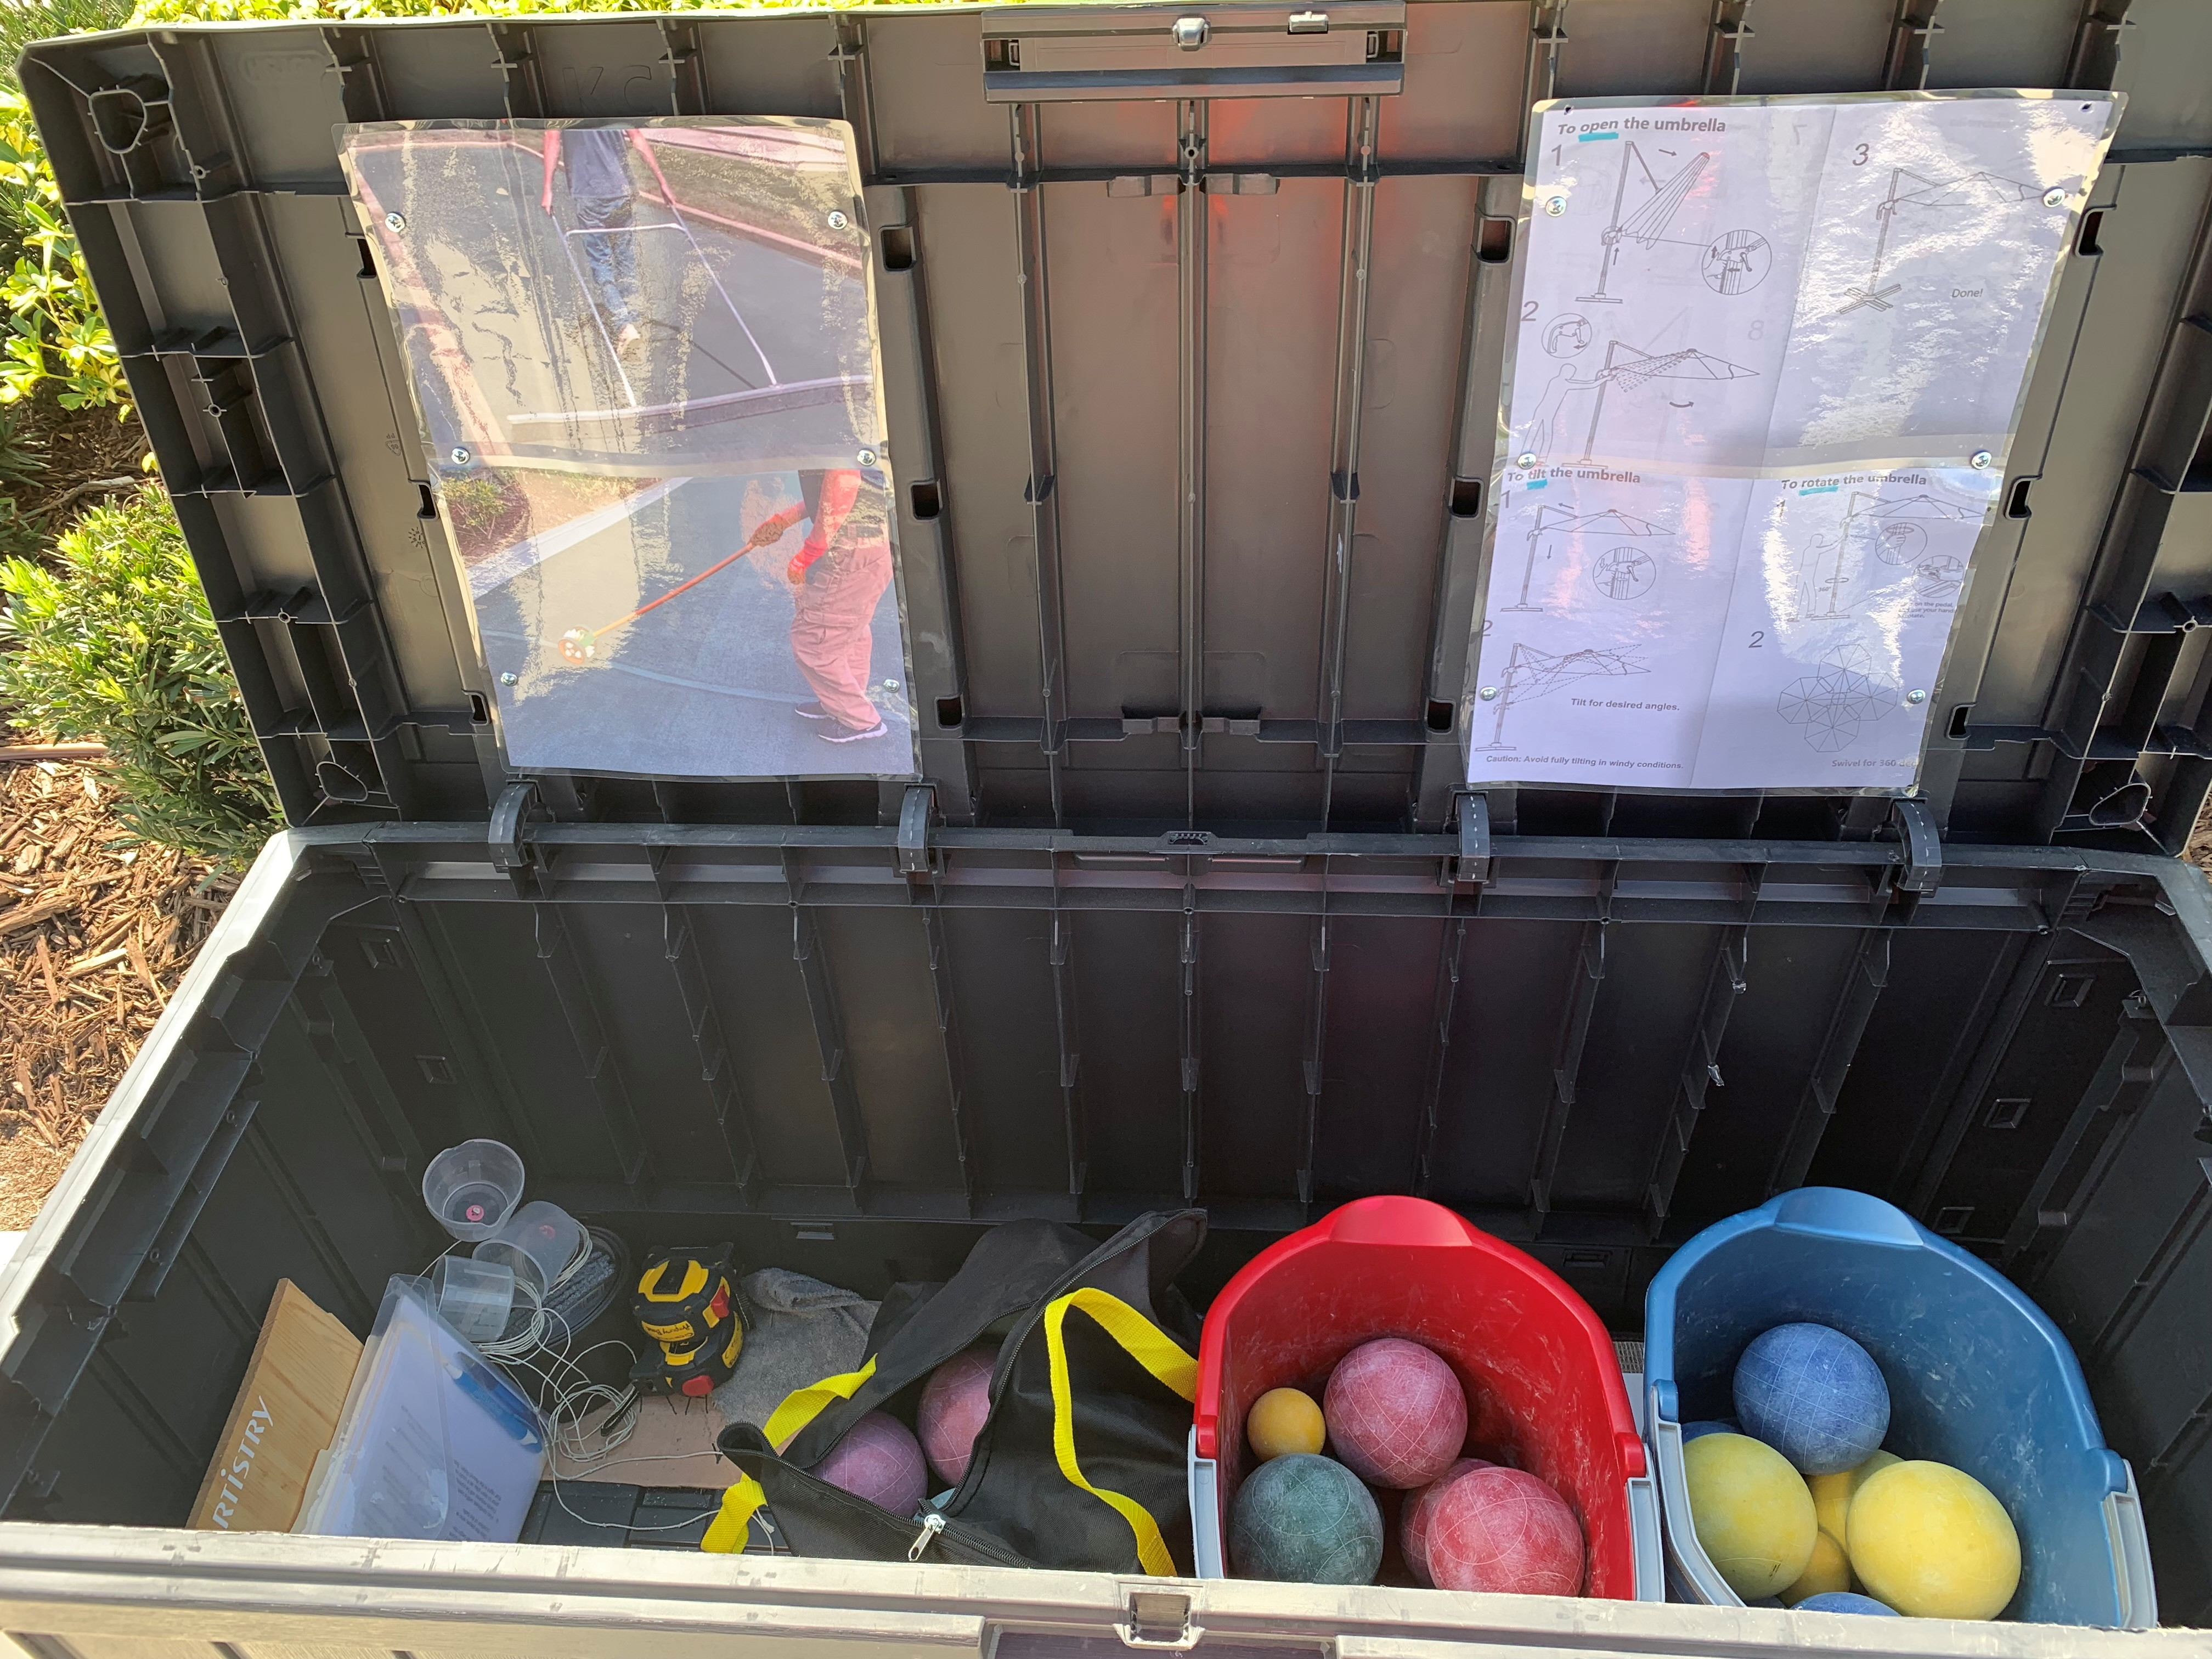

**Fans (2) and Electric Outlet (1)**

* Breeze will maintain as needed.

### Shade Umbrellas

* Breeze will maintain as needed, including proper placement in courts’ area. “How to” use instructions are posted in container and instruction manual is enclosed for carry to umbrella.
* Umbrellas can be OPENED, TILTED and ROTATED. See HOW TO below:

When CLOSE tie around both Green Umbrella Material *and* Pole

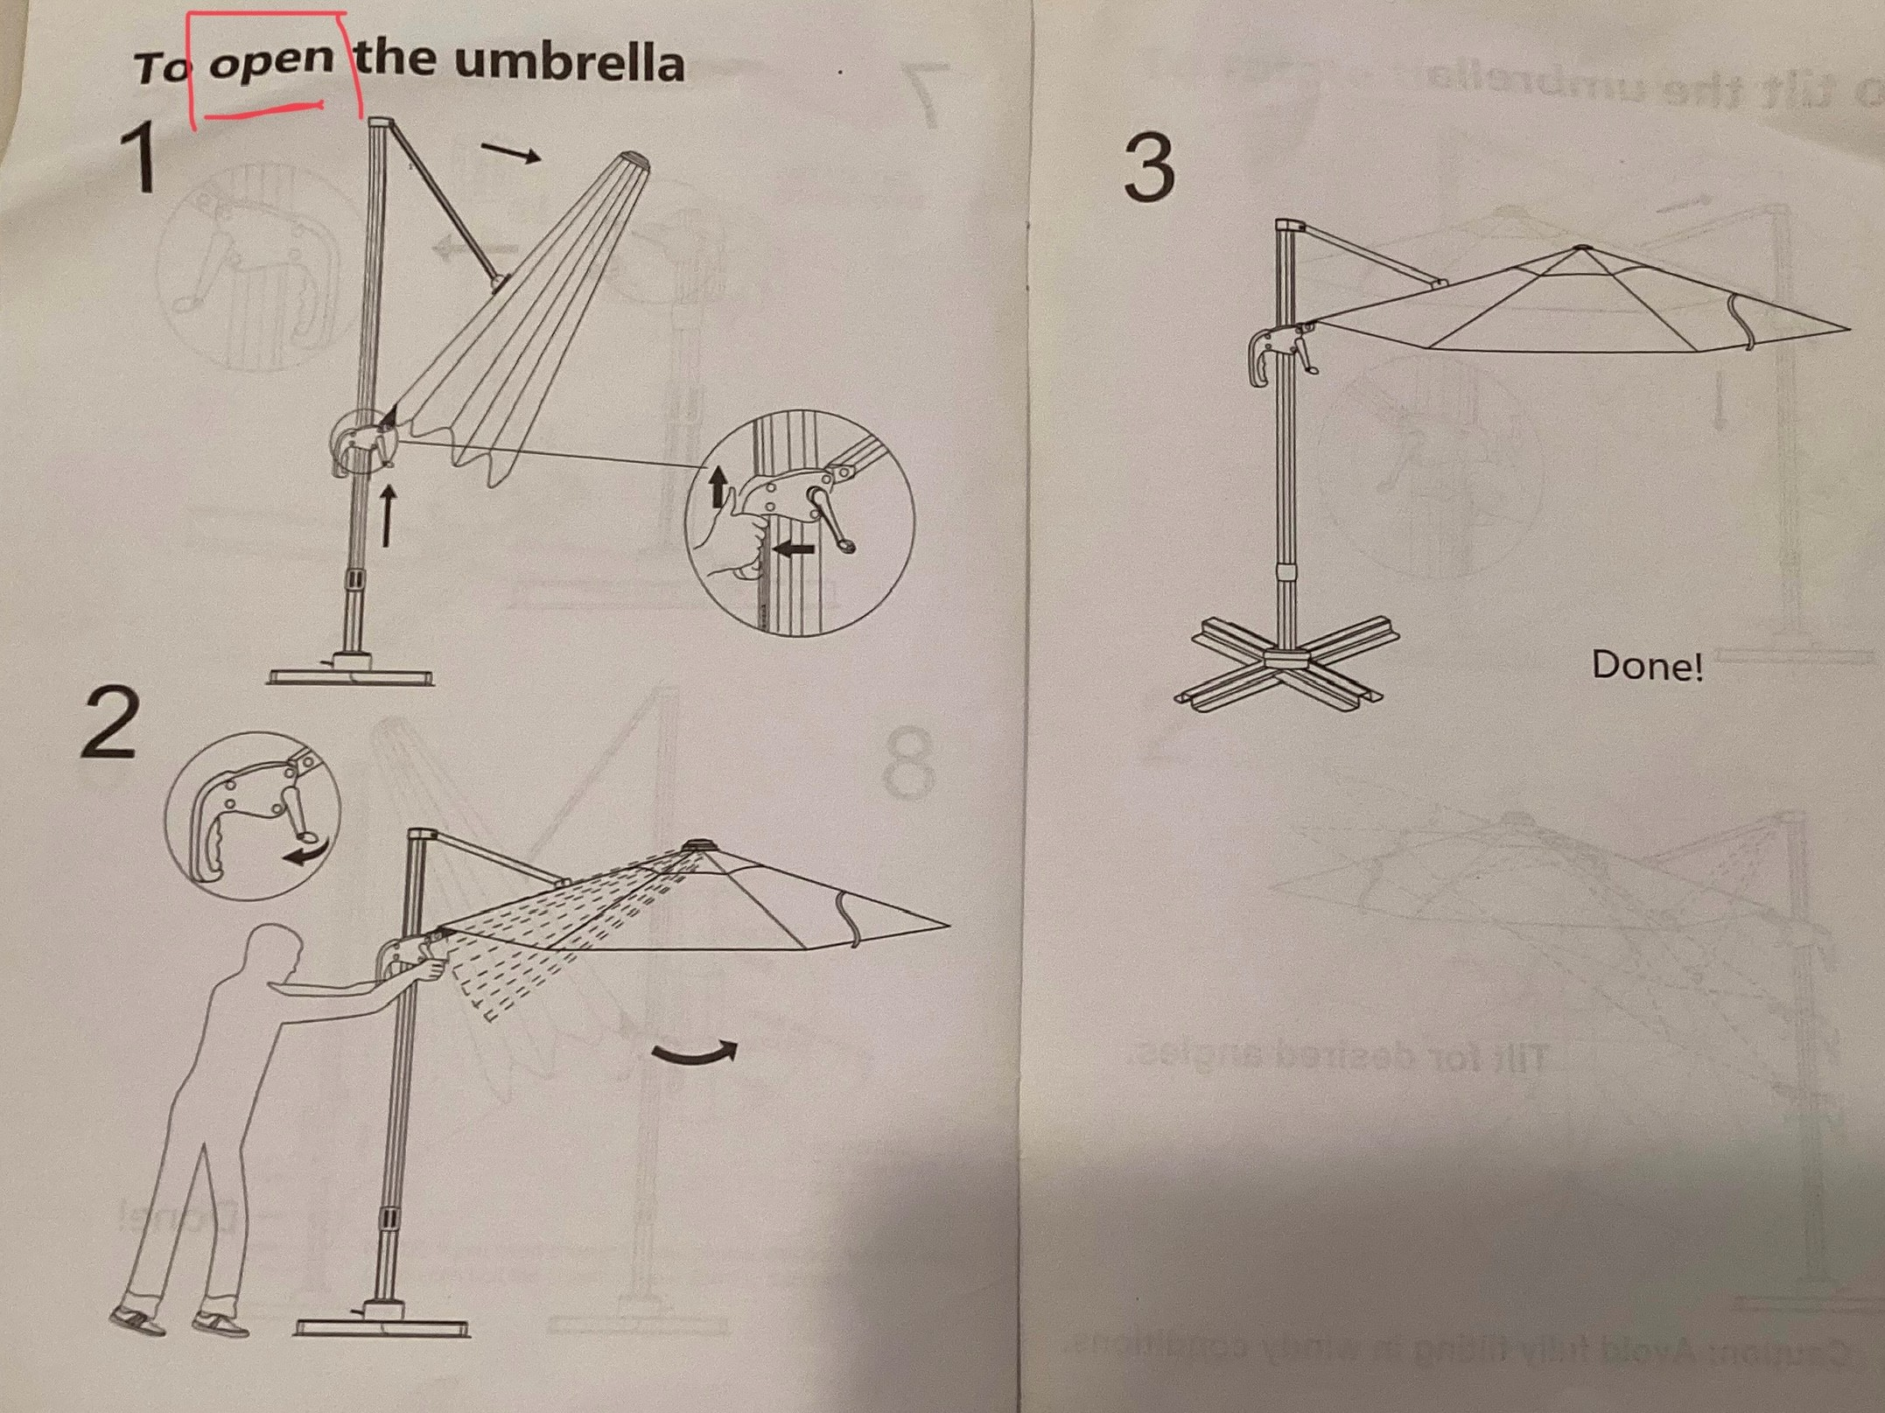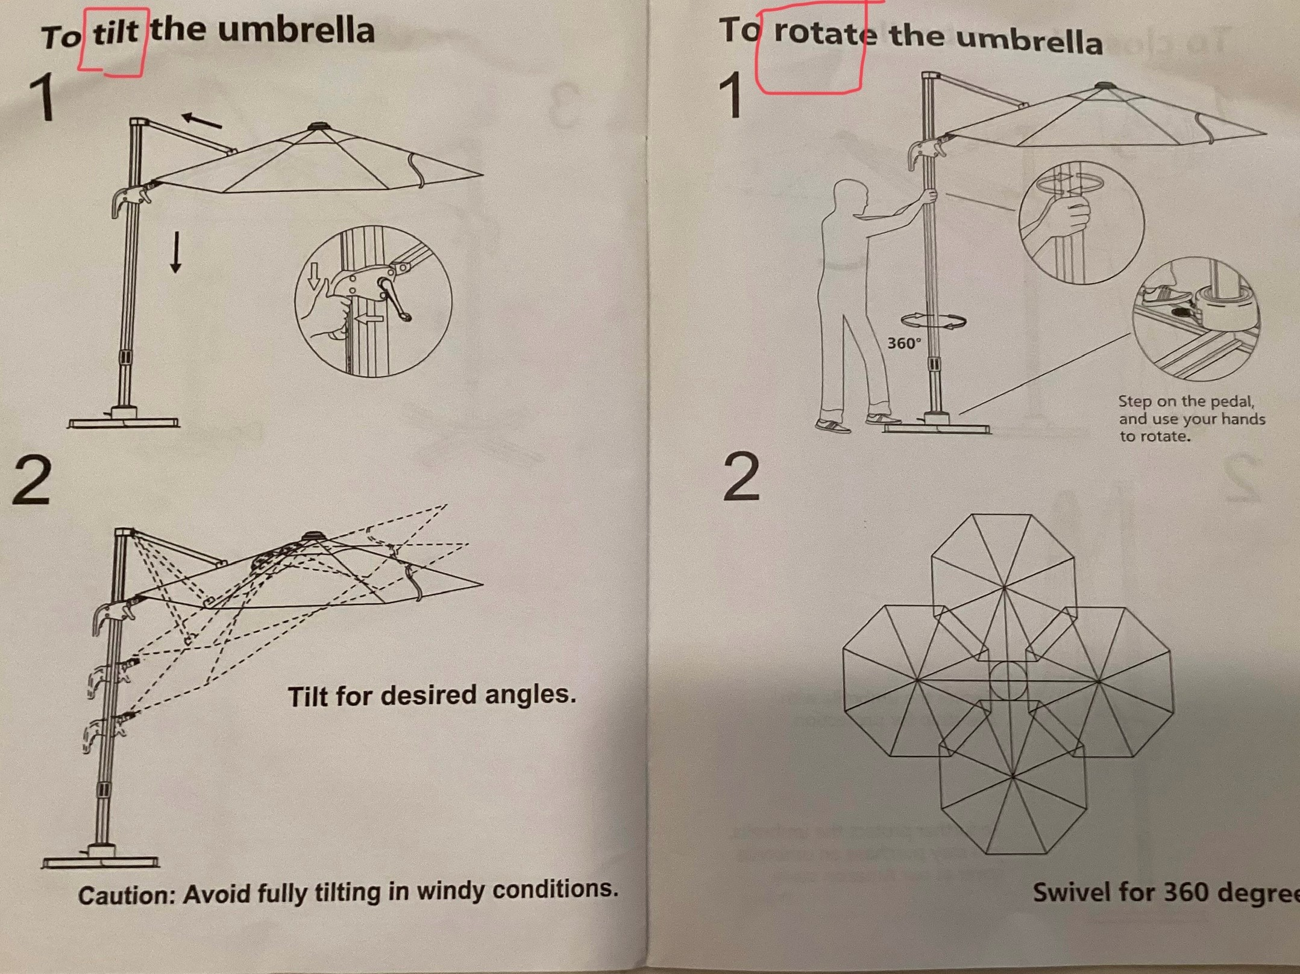

**Shade Canopy, four benches , four end-tables, two Hi-top tables**

* Breeze will maintain as needed, including proper placement in courts’ area.

**Trash**

* Breeze (using janitorial service) will remove as needed

**Pressure Wash area including Canopy**

* Breeze Maintenance Supervisor will do as needed.

# CRESSWIND BOCCE CLUB

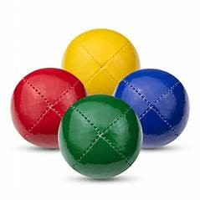

**Team play occurs every week** **on scheduled days / times**

**4 team members (minimum) per Team**

**For more information about forming a Team contact Dee at** datrifiletti@att.net

## Bocce is easy to learn

**No prior experience needed to join the fun!**



**Want to learn more about playing Bocce?**

**Interested in joining the Bocce Club?**

**Then join us at the Cresswind Clubhouse April 10th at 4 PM or**

**October 16th at 4 PM**

**No prior experience or equipment needed You’ll be playing Bocce that evening!**

### ___________________________________________________________________

**Please let us know you will be joining us by sending an email to Angelo Renna at EmmaMargo1234@gmail.com use “Interested in Bocce” as the subject line**

**More information will be provided that evening on how to participate in Bocce Club play**