**Sarasota Eatz Menu for Today**

**All meals served with Chips and Nancy Jean’s Cole Slaw**

**The Ringling Philly -shaved Angus roast beef, peppers, onions, mushrooms, and provolone mozzarella cheese on a toasted sub roll. 15**

**Sun King Grilled Cheese —three kinds of cheese, bacon, grilled tomatoes with a balsamic glaze, grilled on sourdough bread 12**

**Rueben the Right Way-Rye bread grilled with freshly sliced corned beef, Swiss cheese, sauerkraut, and thousand island dressing. 13**

**The Downtown Burger- Fresh ground Angus beef patty with gorgonzola cheese, caramelized onions, and balsamic reduction drizzle on a grilled Kaiser roll. 14**

**The Siesta Key Burger- Fresh ground Angus beef patty, applewood smoked bacon, cheddar cheese, topped with a fried egg on a grilled Kaiser roll. 13**

**The Lido Key Burger- Fresh ground Angus beef patty with choice of American, Swiss, or Cheddar cheese. Topped with lettuce, tomato, and pickle on a grilled Kaiser roll. 12**

**Sarasota Dog- Nathan’s all-beef large hot dog stuffed with cheese and wrapped in bacon, deep fried and grilled served on a hot dog bun 11**

**Payne Park Dog- Nathan’s all beef large hot dog wrapped in applewood bacon, deep fried, basted with barbeque sauce, served in bun with cream cheese and chives, topped with everything bagel seasoning, and fresh chives. 11**

**The Selby Chicken Sandwich- Chicken breast grilled with your choice of cheese and toppings served on a toasted Kaiser Roll. 13**

**Chicken Strips- Four Fried Strips** **12**

**Ca’d’Zan Fries- Large order of fries grilled with mozzarella provolone whole milk cheese, drizzled with balsamic glaze and topped with chives. 8**

**Order of Fries- 5**

**Sweet potato Fries- 6**

**Substitute for Fries- + 2**

**Today’s Special**

**“The Purple Cow”**

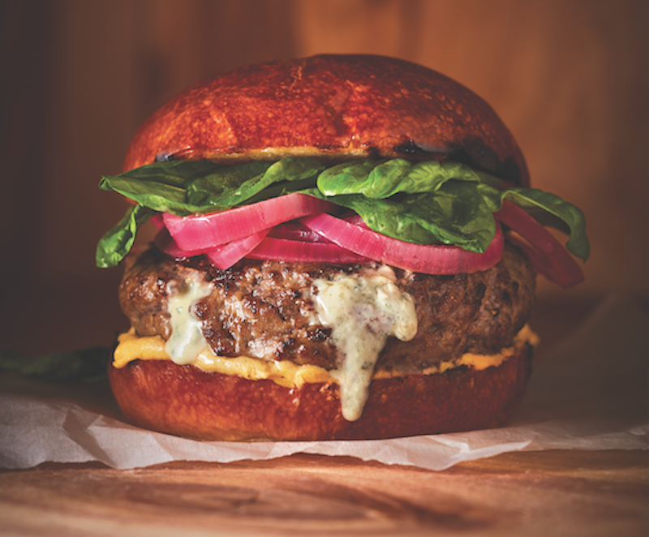

**¾ pound of Angus beef, Brie, homemade pickled red onions, truffle aioli, on a toasted pretzel bun Served with sweet potato fries and Nancy Jean’s coleslaw.**

**$20**